**Using IIS Manager user interface to create a handler mapping for PHP**

Follow these steps to create an IIS handler mapping for PHP in IIS Manager user interface:

1. In the Windows Start Menu choose "Run:", type "inetmgr" and click "Ok";
2. In the IIS Manager user interface select the server node in the "Connections" tree view;
3. In the "Features View" page open the "Handler Mappings" feature;

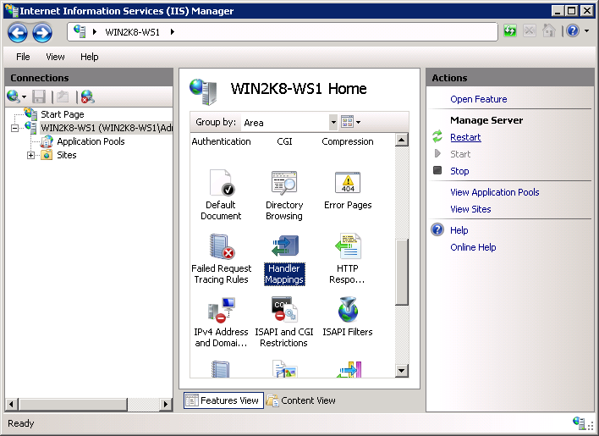

1. In the "Actions" pane click "Add Module Mapping...";
2. In the "Add Module Mapping" dialog enter the following:
3. Request path: *.php
4. Module: FastCgiModule
5. Executable: C:\[Path to PHP installation]\php-cgi.exe
6. Name: PHP_via_FastCGI
7. Click "Request Restrictions" button and then configure the mapping to invoke handler only if request is mapped to a file or a folder;
8. Click OK on all the dialogs to save the configuration.

